**Key points, detectors and descriptors :**

**(1) Harris :**

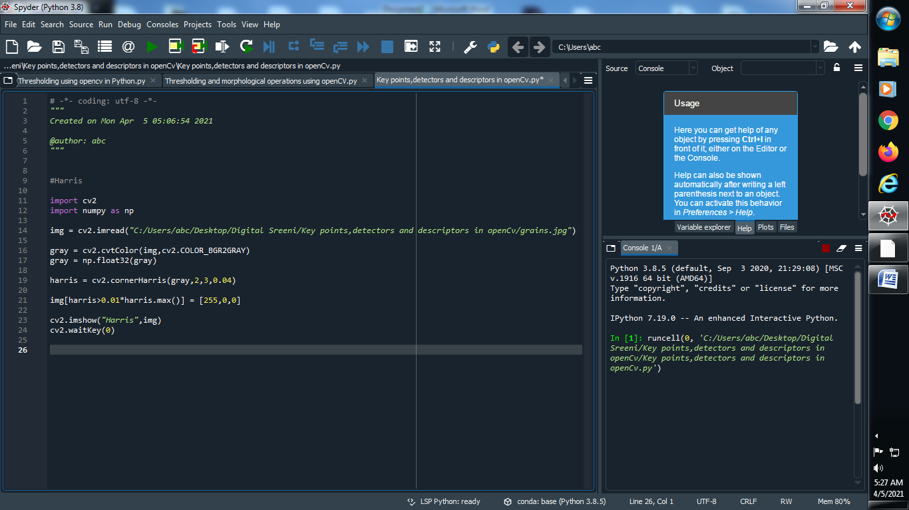

**→ Output :**

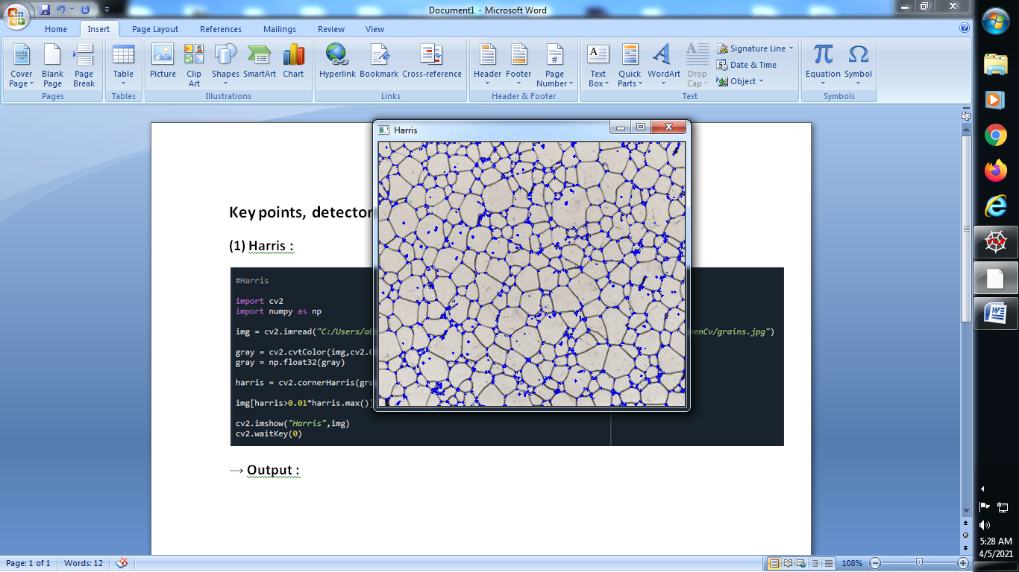

**(2) Shit-Tomasi Corner Detector & Good Feactures to Track :**

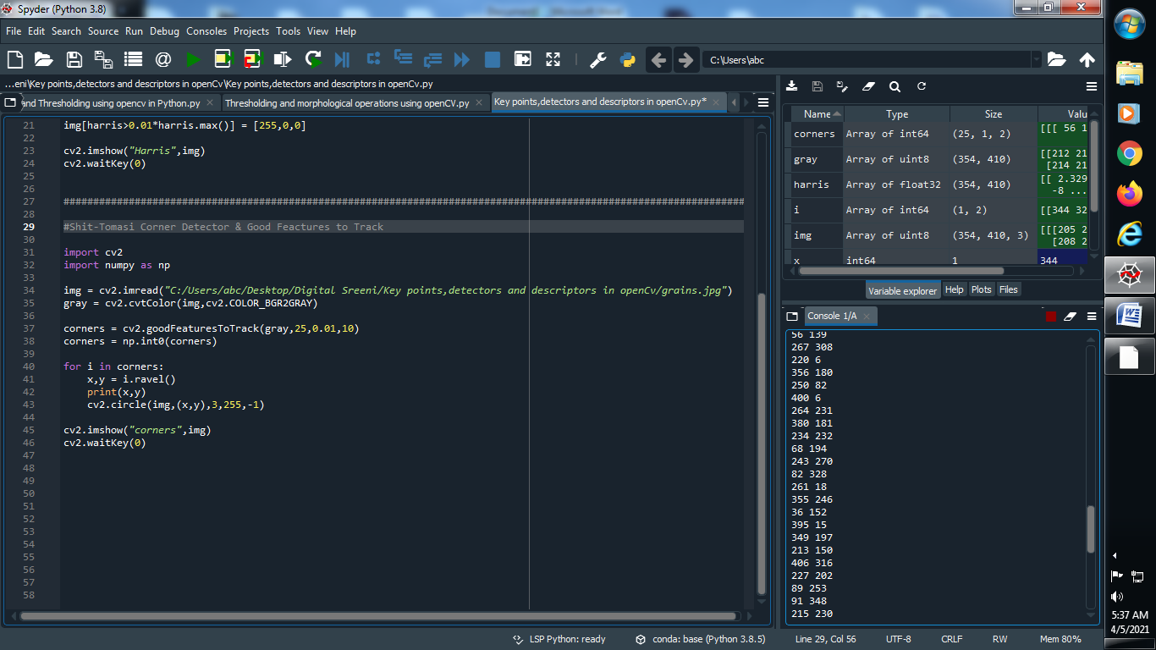

**→ Output :**

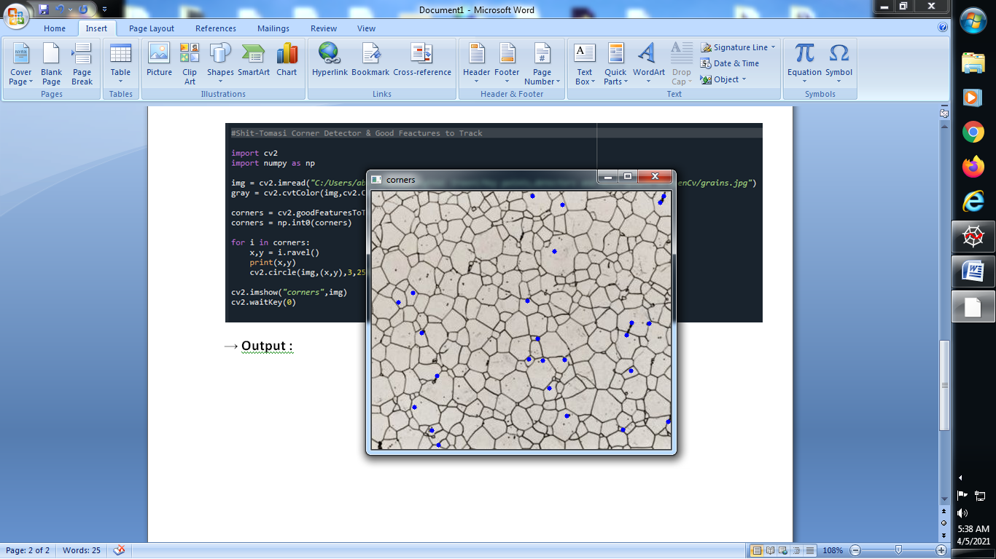

**Note : Above two methods harris and Shit-Tomasi both are keypoints of OpenCv.**

**(3) Fast Algorithm for corner Detection :**

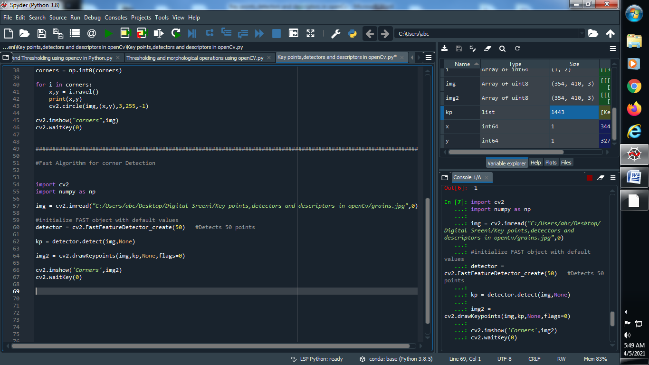

**→ Output :**

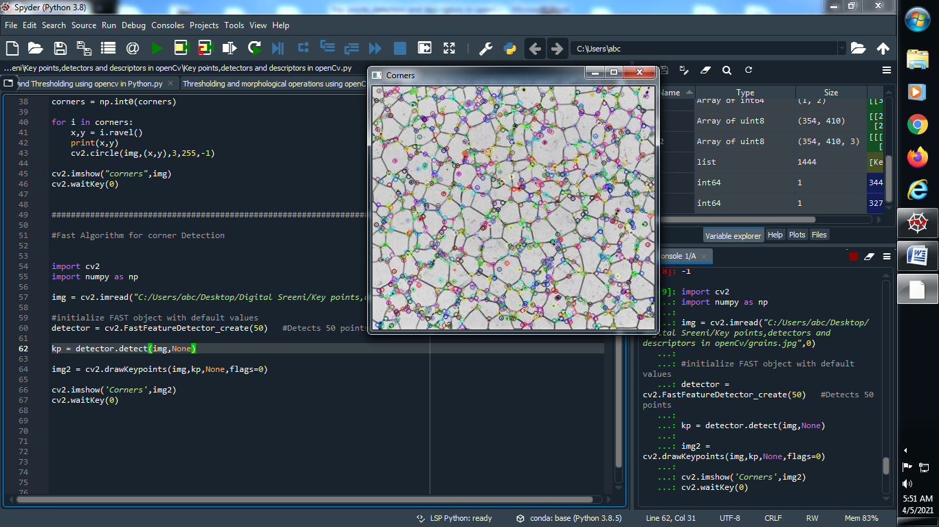

**Note : Fast Algorithm for corner Detection is feature detector .**

**(4)** **ORB (Oriented FAST and Rotated BRIEF) :**

**→ Note : FAST is a detector and BRIEF is a descriptor.**

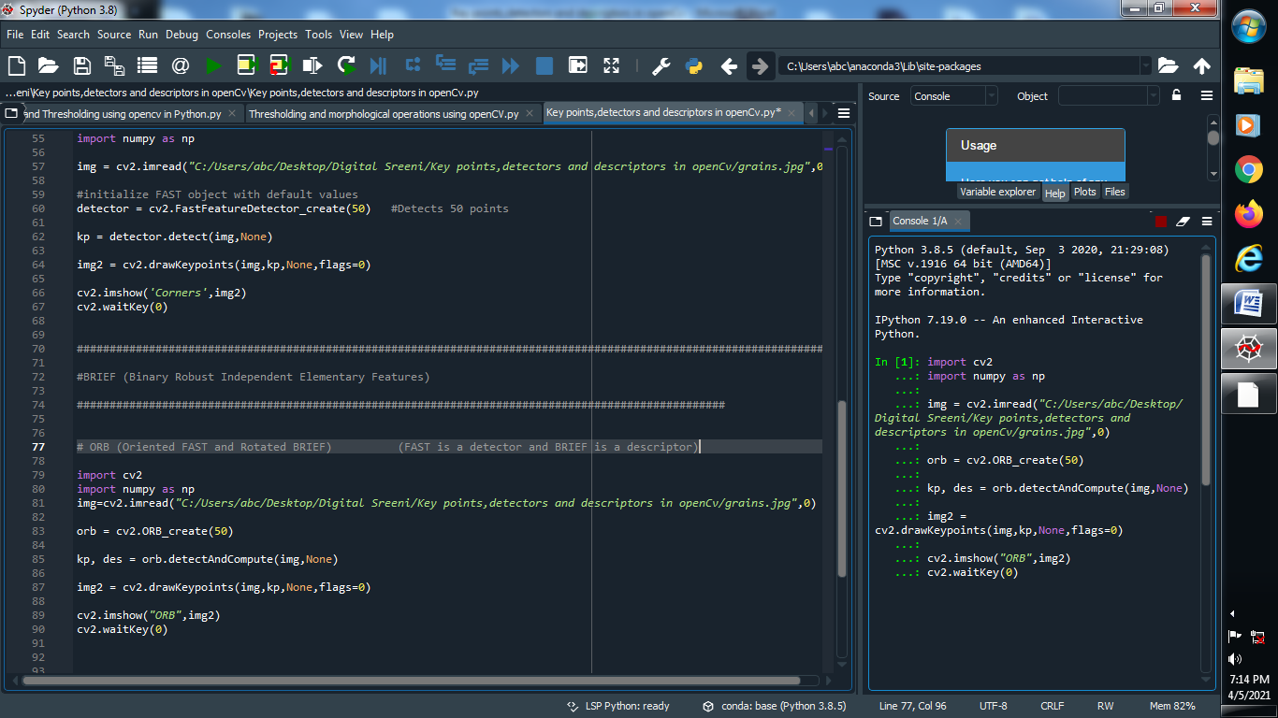

**→ Output :**

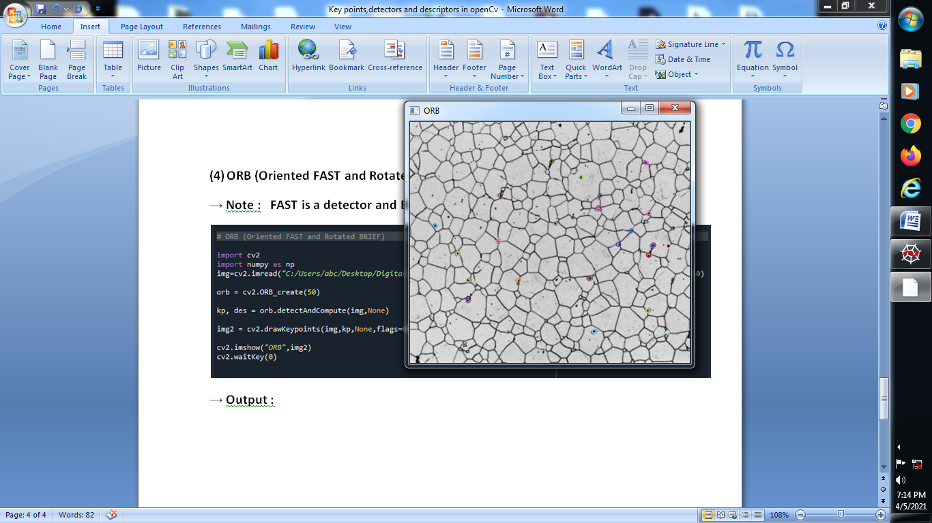

**→ Now Change the flag value for the better understanding :**

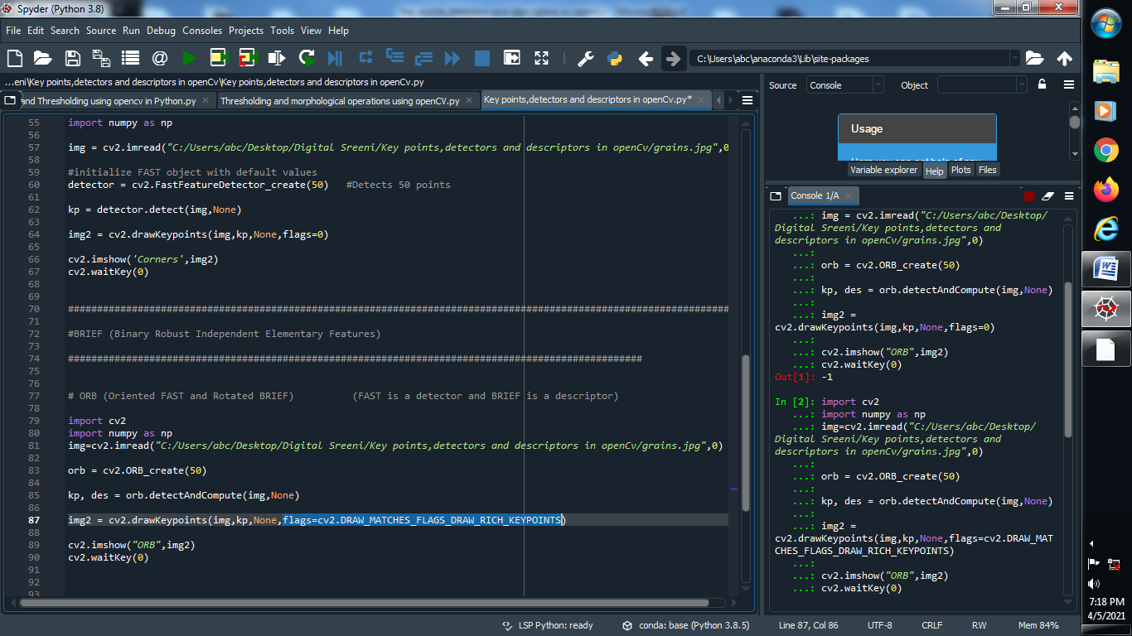

**Output :**

